**ANDROID DEVELOPMENT**

**A INTERNSHIP REPORT**

***Submitted by***

**Makawana Mohit**

**226340316036**

***In partial fulfillment for the award of the degree of***

**DIPLOMA IN ENGINEERING**

***in***

**Information Technology**

**LUKHDHIRJI ENGINEERING COLLEGE (DIPLOMA), MORBI**

 

**Gujarat Technological University**

**[08-2023]**

 

**LUKHDHIRJI ENGINEERING COLLEGE**

**(DIPLOMA)**

**CERTIFICATE**

This is to certify that the project report submitted along with the project entitled **Android development** been carried out by **Mohit Makawana** under my guidance in partial fulfillment for the degree of Diploma in Engineering in **Information Technology,** **3rd** Semester of Gujarat Technological University, Ahmadabad during the academic year 2022-23.

Internal Guide                                                                      Head of the Department  
  
   
  
**DECLARATION**

We hereby declare that the Internship  report submitted along with the **Android Development** submitted in partial fulfillment for the degree of **Diploma** in Engineering in **Information Technology** to Gujarat Technological University, Ahmedabad, is a bonafide record of original project work carried out by me At Brainybeam Info-Tech PVT LTD**.** under the supervision of **Sagar jasani** and that no part of this report has been directly copied from any students’ reports or taken from any other source, without providing due reference.

Name of the Student                                                                           Sign of Student

**Mohit Makawana**

Joining Letter:

* **WHAT I LEARN! ( MODE: ONLINE )**
* **Date : 10th *August** Android Overview

Basic Introduction of Android Development.

Start: 2005 (Google Acquired)

Founder: Andy Rubin

Launched Company: HTC

Android Version:

API : Application Programming Interface

We can say that APIs are the set of protocols and tools used for building software applications.

SDK : Software Development Kit

Android SDK is a collection of libraries and Software Development tools that are essential for Developing Android Applications.

Software For Android development :

Eclipse , Android Studio , Vs Code.

Download android studio : click [here](https://developer.android.com/studio) to download android studio

* **Date : 11th *August** Creating the first APP an understanding file system

Creating the frist project and understanding java package / SDK /API etc.

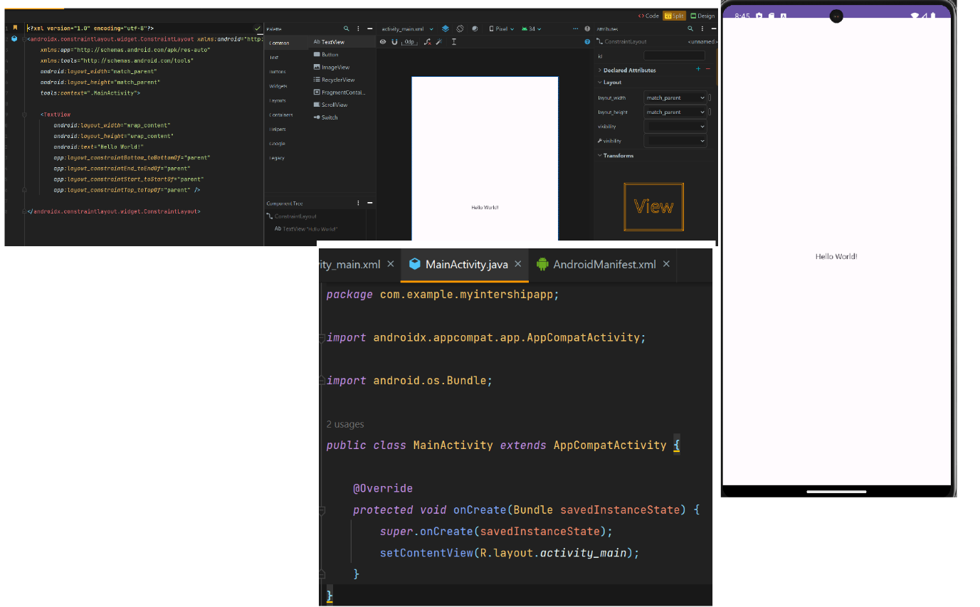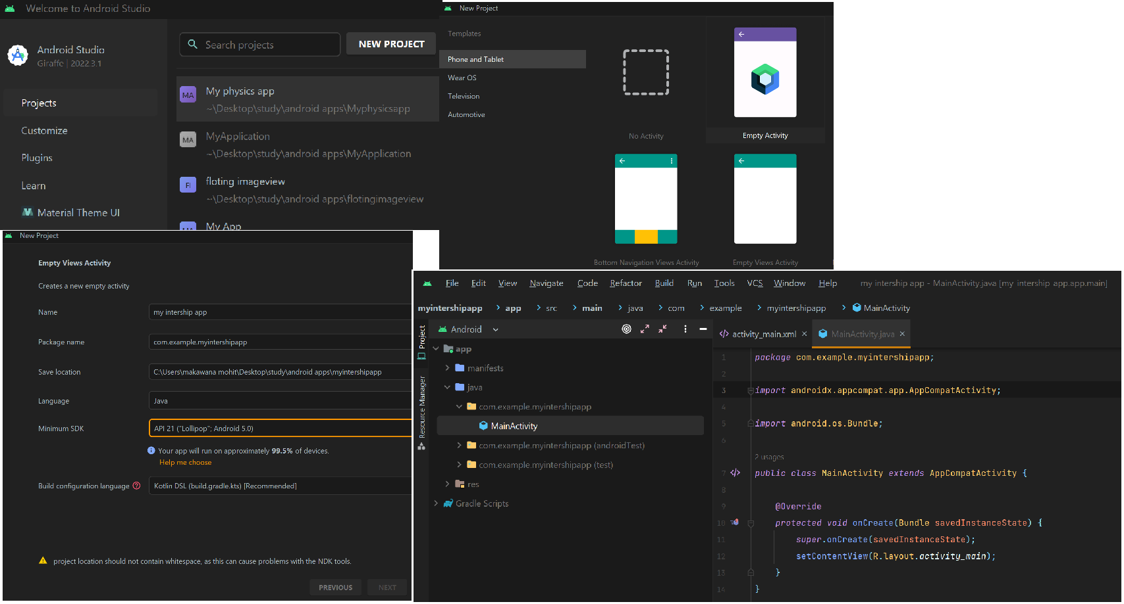firsr hello world program

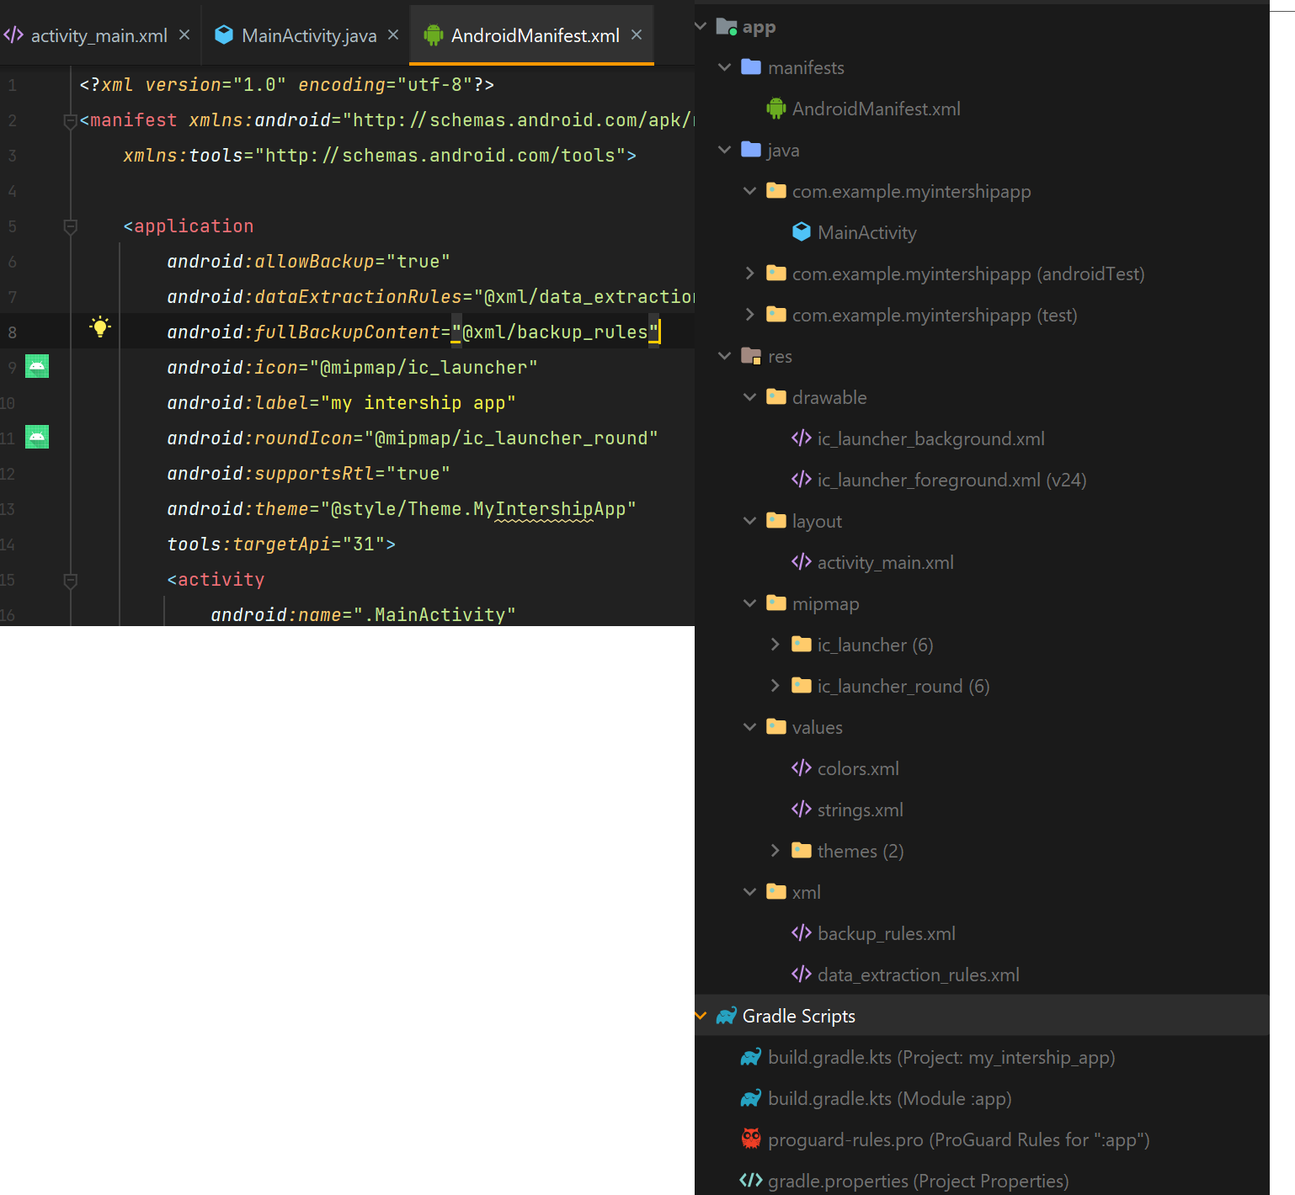understading the work of all files ie. Colors/icon /gradel Dependency ect.

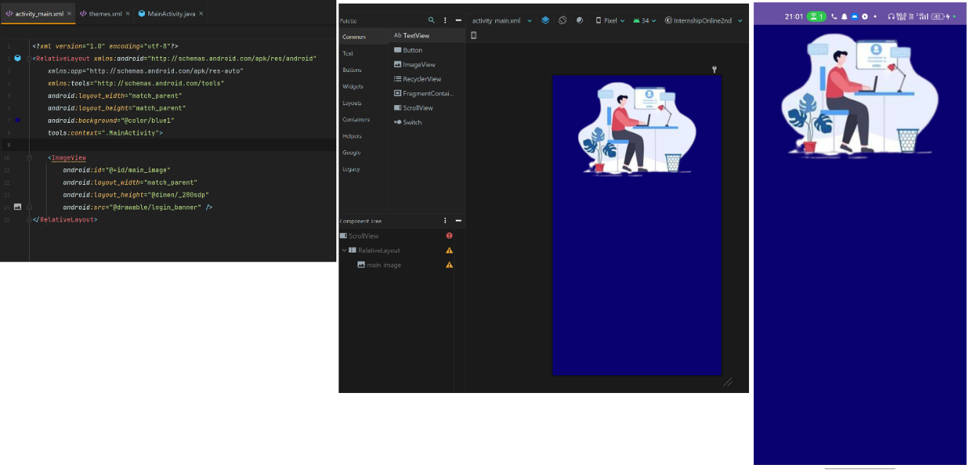Settings background and image view for creating login ui /page

* **Date : 14th *August** Making the response login UI using colors/theme/fonts/SDP

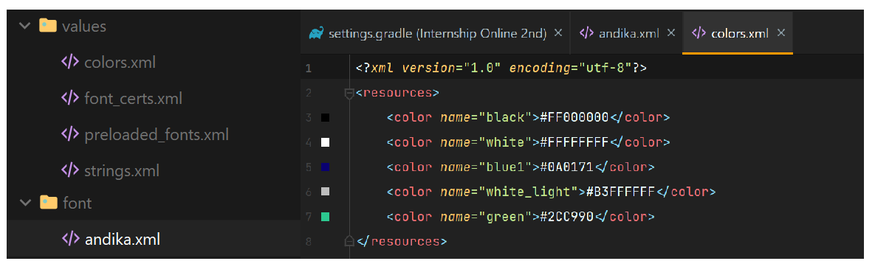Adding fonts and colors for the login ui

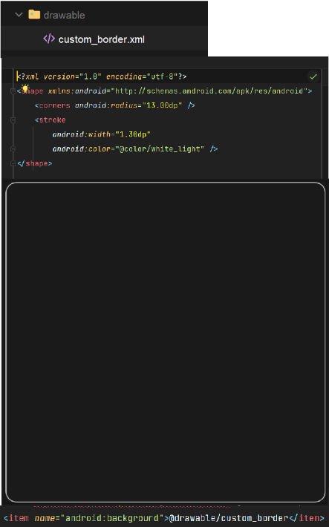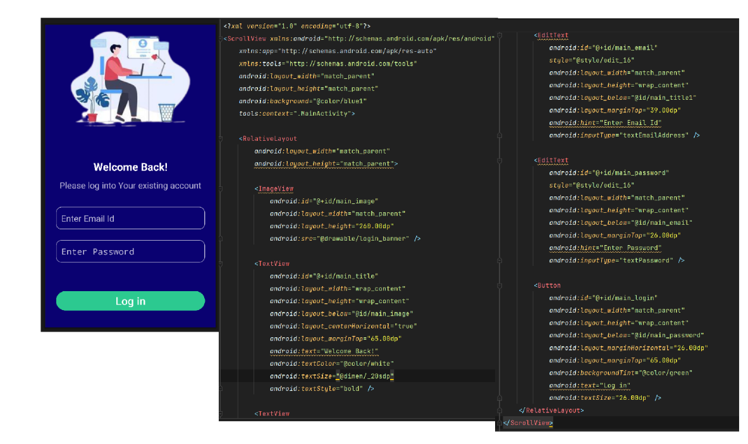Now completing the login ui using fonts colors making border for email using drawable file

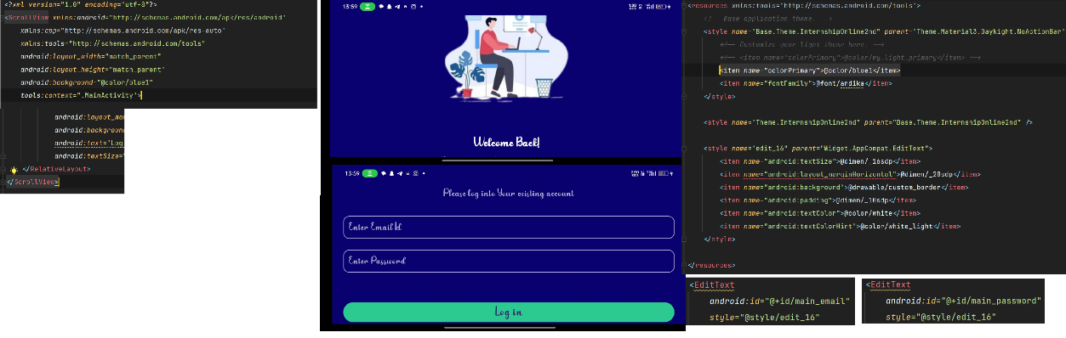Making scroll view for landscape view/ and making theme style for same code to make code less and small/making action bar same as bg color

Making app Responsive you using 3rd party library SDP/first add Dependency in gradel file the use sdp in change of dp(note: I can’t add pic of phone/tablet because I didn’t have emulator for that)



* **Date : 16th *August** working with java file /publish code of github

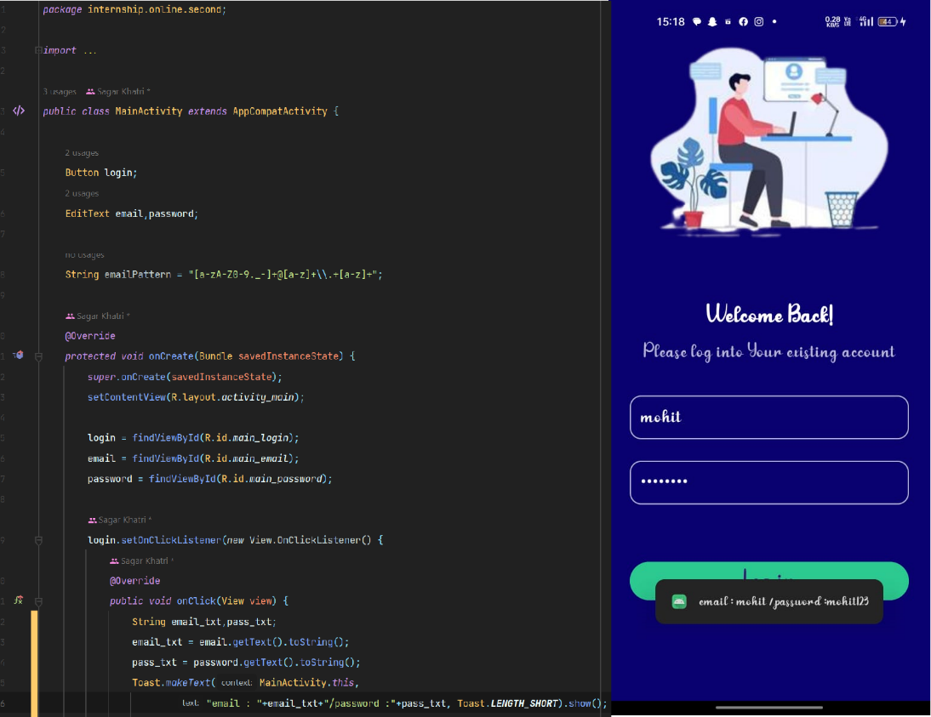Getting widget of XML file into java file and getting value of them/ through on click listener on button.

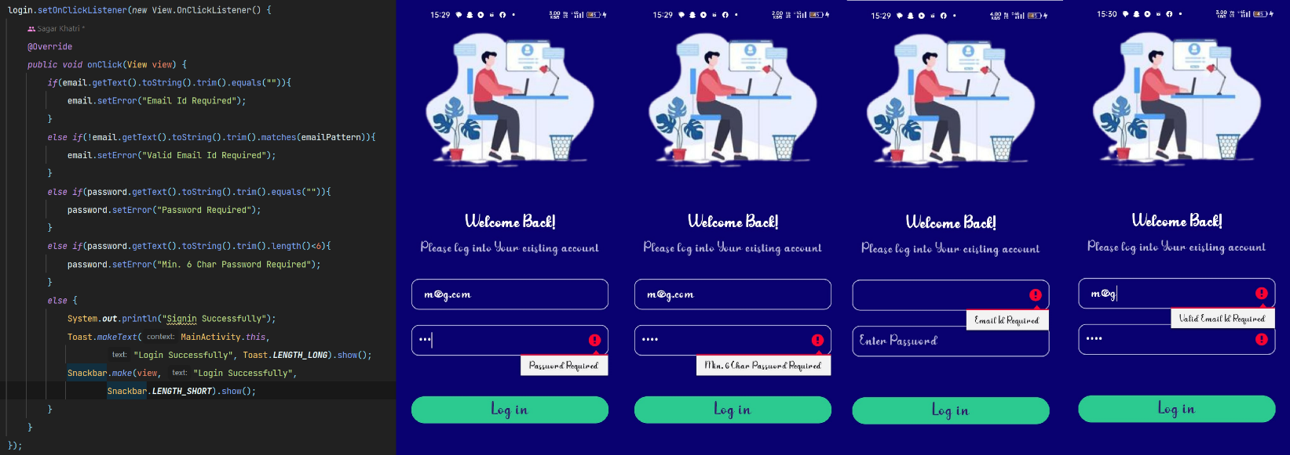Now adding validation error for blank email/password ,for password length and for email pattern or email format

Publishing the app in the github

To publish the app on github first we have to create the github account . the we have to login in it using token/direct access

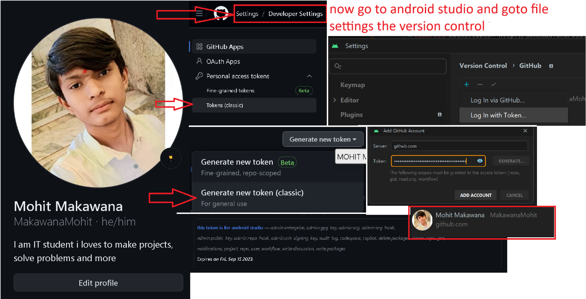

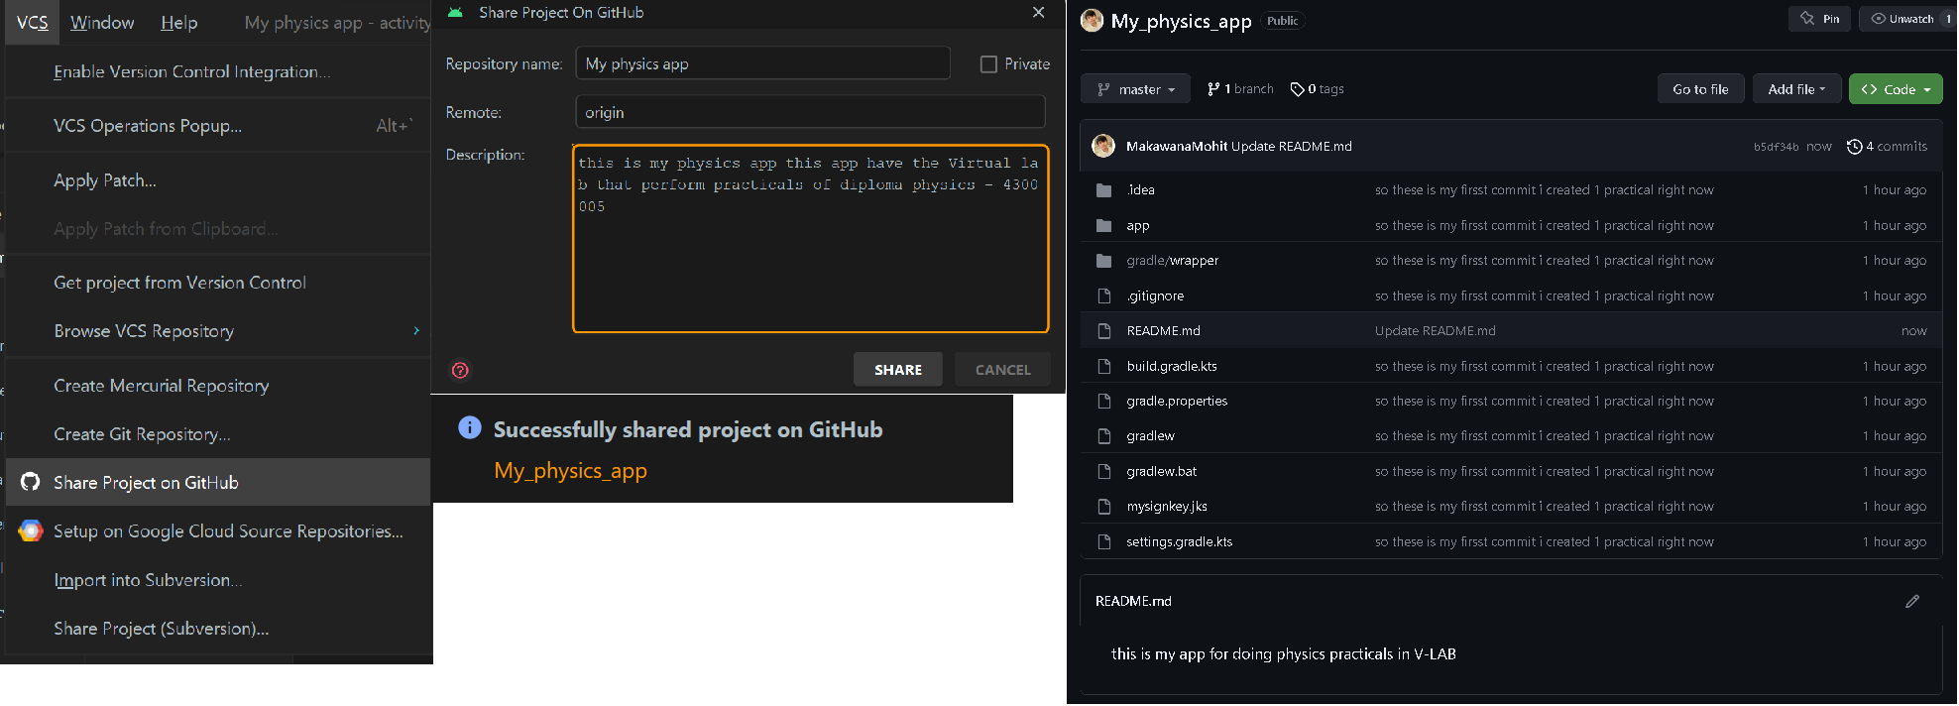After login fir we have to push project on github

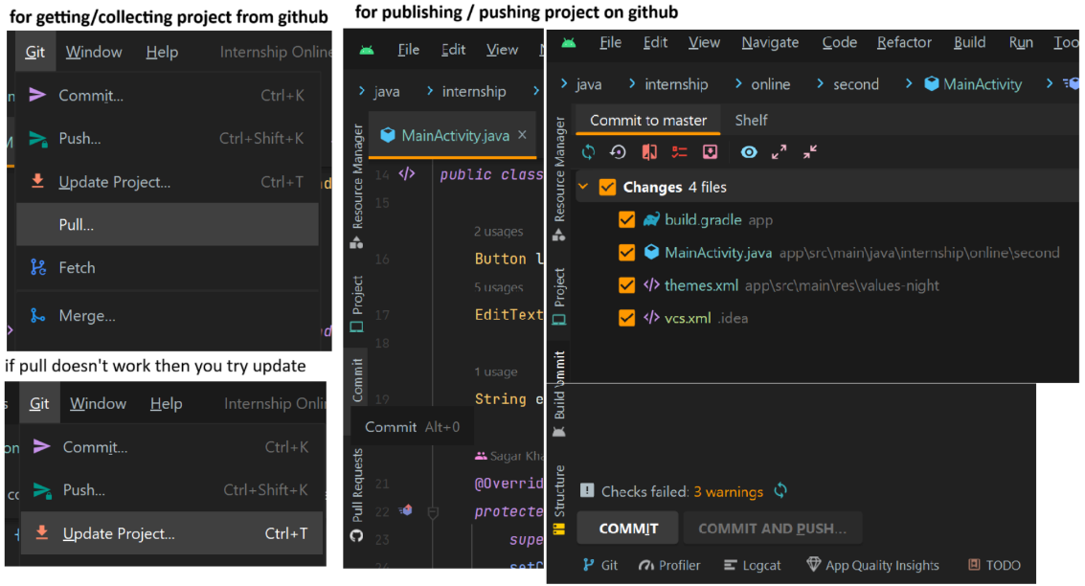Now this is example of how to collect project from github/pull and push to the github /commit

* **Date : 17th *August** Making the app Multi screen and adding the signup page

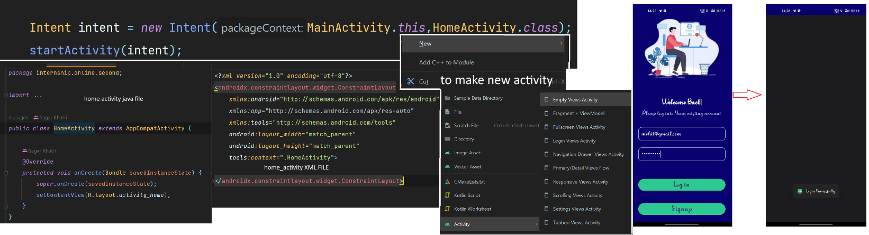**Making the intent and start new activity using that intent**

**Now making signup page for registration of user [using intent and validation]**

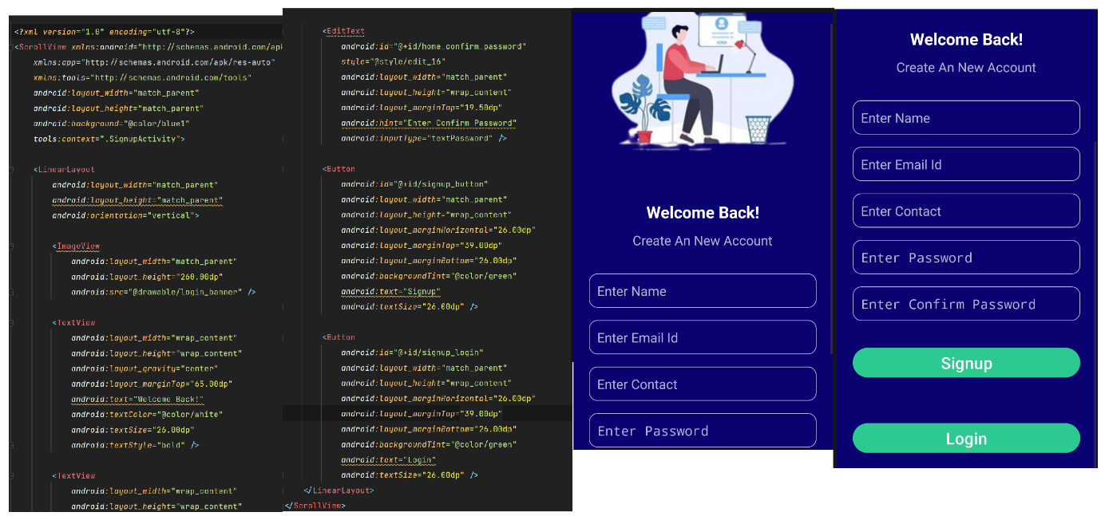Xml Layout for signup page

Adding validation for signup page using java

Java code for validation

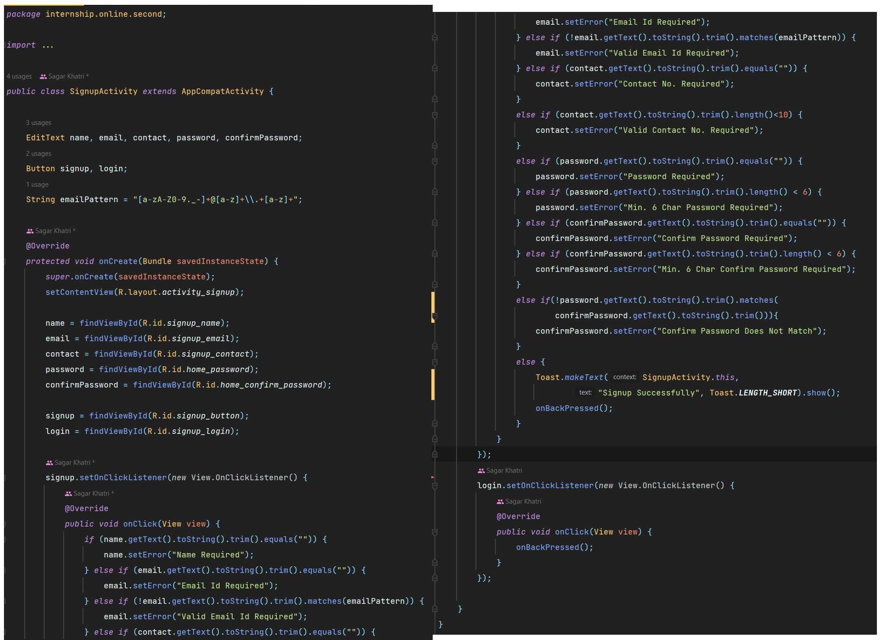

Validation errors

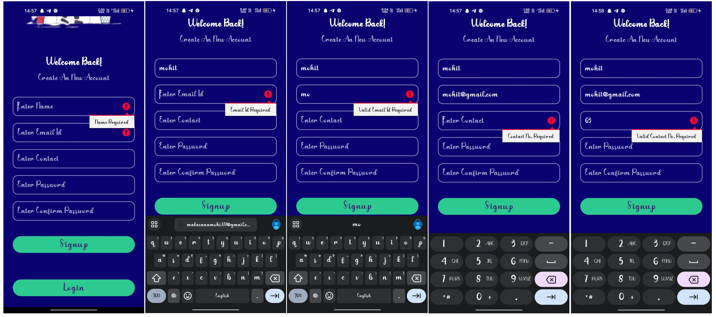

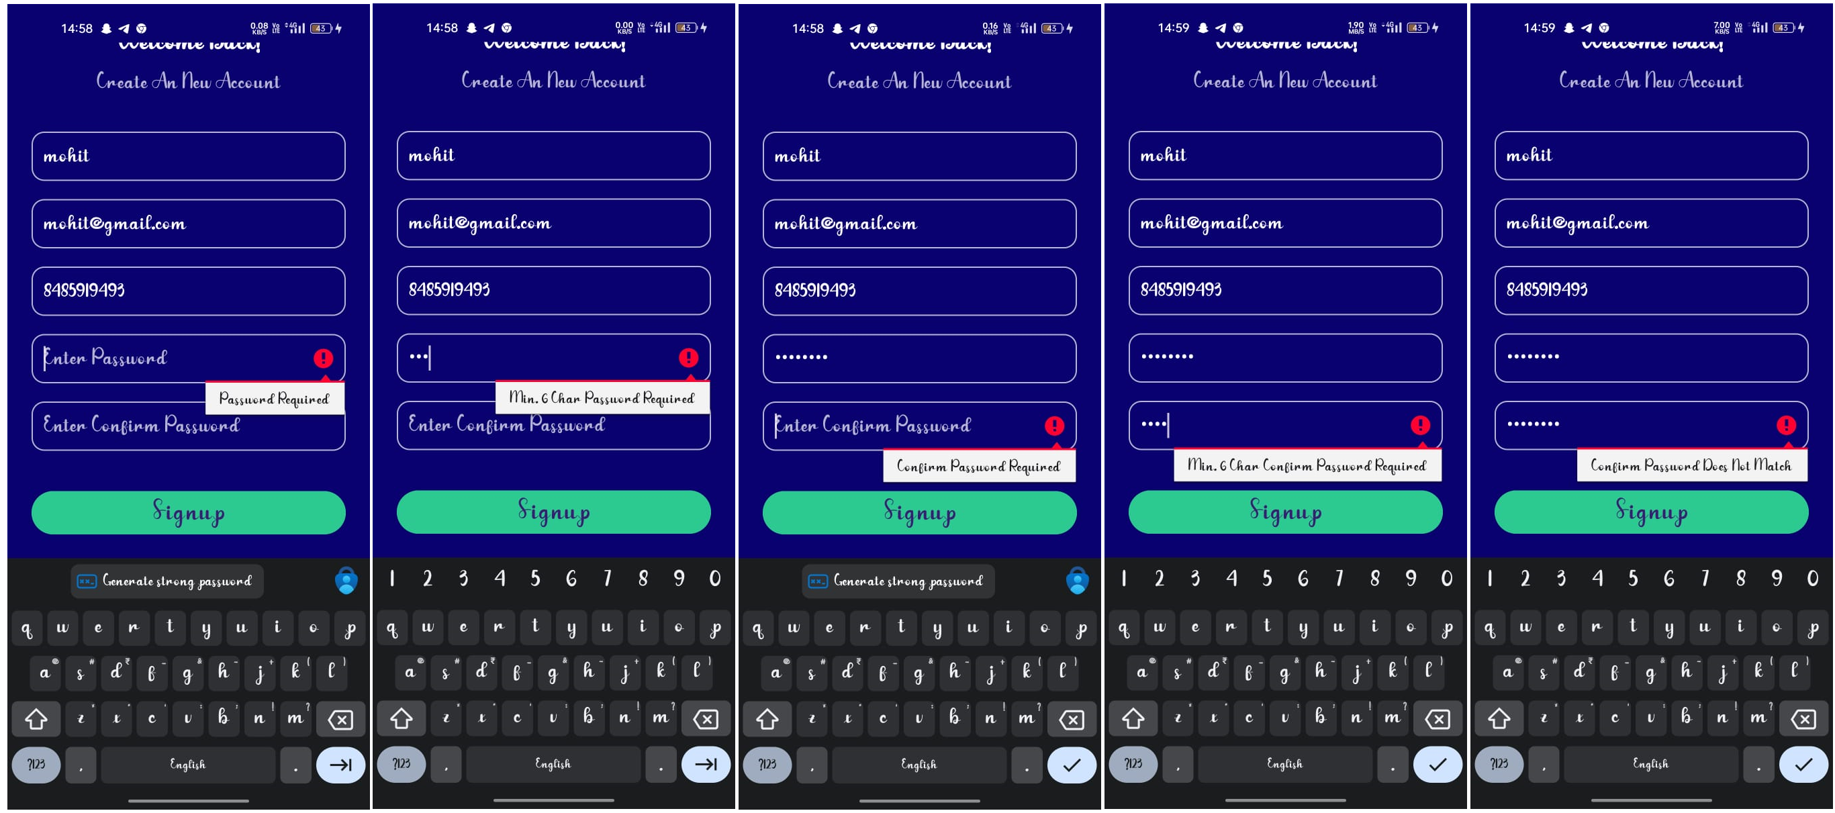

* **Date : 17th *August** getting the basic knowledge about database : types of database ,different types of data for storing different information / data

Types of database and their uses:

* Dbsqlite : **it is mainly use in android and python**
  + DBSQLite is a lightweight, serverless relational database management system. It excels in embedded applications, storing data in a single file without requiring a dedicated server. Offering SQL support, it efficiently manages structured data and is popular in mobile apps, desktop software, and small-scale projects. Its simplicity, portability, and low resource demands make it a versatile choice for local data storage and retrieval.
* Musql: **widely used in web app**
  + MySQL is an open-source relational database management system that efficiently organizes and stores data. It offers robust data retrieval, manipulation, and management capabilities through structured query language (SQL). With a strong emphasis on speed, security, and scalability, MySQL is widely used for web applications.
* Nosql**: it is used in realtime uses like showing online status in Whatsapp etc.**
  + NoSQL (Not Only SQL) is a database approach divergent from traditional relational databases. It employs flexible data models, such as key-value, document, column-family, and graph, to accommodate various data types and structures. Suited for scalable, distributed systems.

**Data types for database:**

1. **Integer:**

**Description: Whole numbers without decimal points.**

1. **Tiny Int (tinyint):** A very small integer type typically occupying 1 byte. It has a limited range, often from 0 to 255 or -128 to 127, depending on whether it is treated as unsigned or signed.

2. **Small Int (smallint):** A small integer type usually occupying 2 bytes. It can store a larger range of values compared to tiny int, often from -32,768 to 32,767.

3. **Integer (int):** As explained earlier, the standard integer type usually occupying 4 bytes. It can store values within a moderate range.

4. **Big Integer (bigint):** A larger integer type typically occupying 8 bytes. It can store significantly larger whole numbers, making it suitable for scenarios requiring extensive numerical ranges.

**2. Floating-Point:**

**Description: Numbers with decimal points, allowing for fractional values.**

**Store Limit: Typically 4 bytes for single-precision (32-bit) and 8 bytes for double-precision (64-bit).**

**3. String:**

**Description: Textual data represented as a sequence of characters.**

**Store Limit: Varies based on database system, often up to several gigabytes.**

**4. Boolean:**

**Description: Represents true or false values.**

**Store Limit: Usually 1 byte, representing either true or false.**

**5. Date and Time:**

**Description: Stores date and time values, often with various levels of precision.**

**Store Limit: Varies based on the database system, often up to microsecond or nanosecond precision.**

**6. Binary:**

**Description: Stores binary data such as images, audio, or files.**

**Store Limit: Varies based on the database system, often limited by the**

**maximum document or row size.**

**7. Array/List:**

**Description: Collection of values of the same data type.**

**Store Limit: Typically limited by the maximum document or row size.**

**8. Object/Document:**

**Description: A complex data type that can store nested values and attributes.**

**Store Limit: Typically limited by the maximum document or row size.**

**9. JSON/BSON:**

**Description: Text-based or binary representation for storing structured data.**

**Store Limit: Varies based on the database system and configuration, often**

**several megabytes.**

**10. UUID (Universally Unique Identifier):**

**Description: A unique identifier often used for distributed systems and data replication. Store Limit: 16 bytes (128 bits).**

* **Date : 21th *August** creating the database and execute SQL queries for creating table and insert data into table.

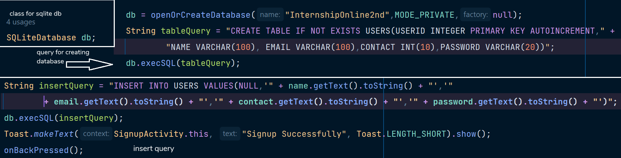**Creating the database**

**Now steps for view the inserted data after query**

* **Copy the database file into you pc/laptop**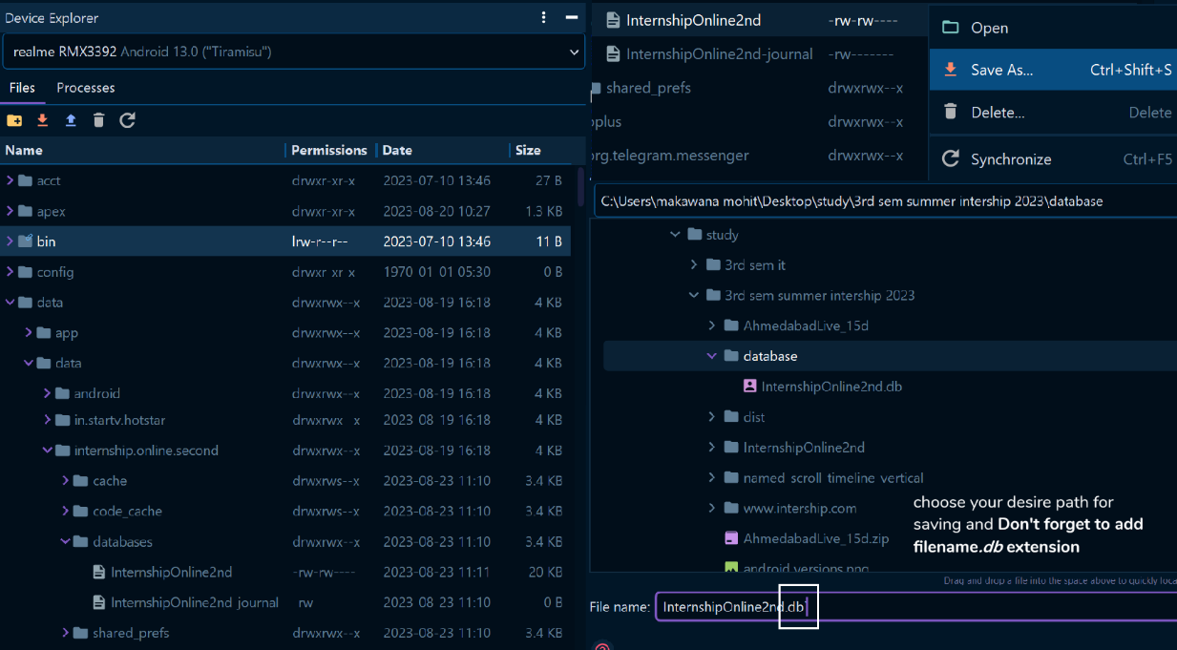

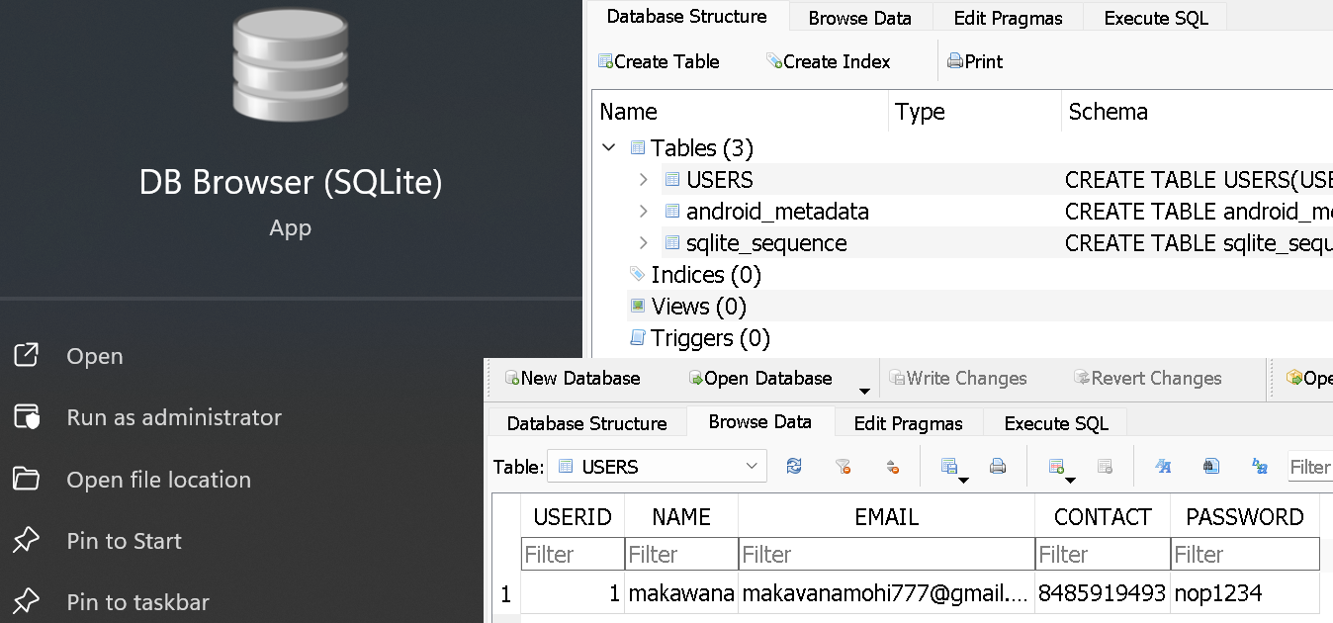**2Download any db browser and open the copied file**

* **Date : 22th *August** learn about select query apply them to : stop registration with same email id and in login form /making password hide and show /changing the icon of app
* 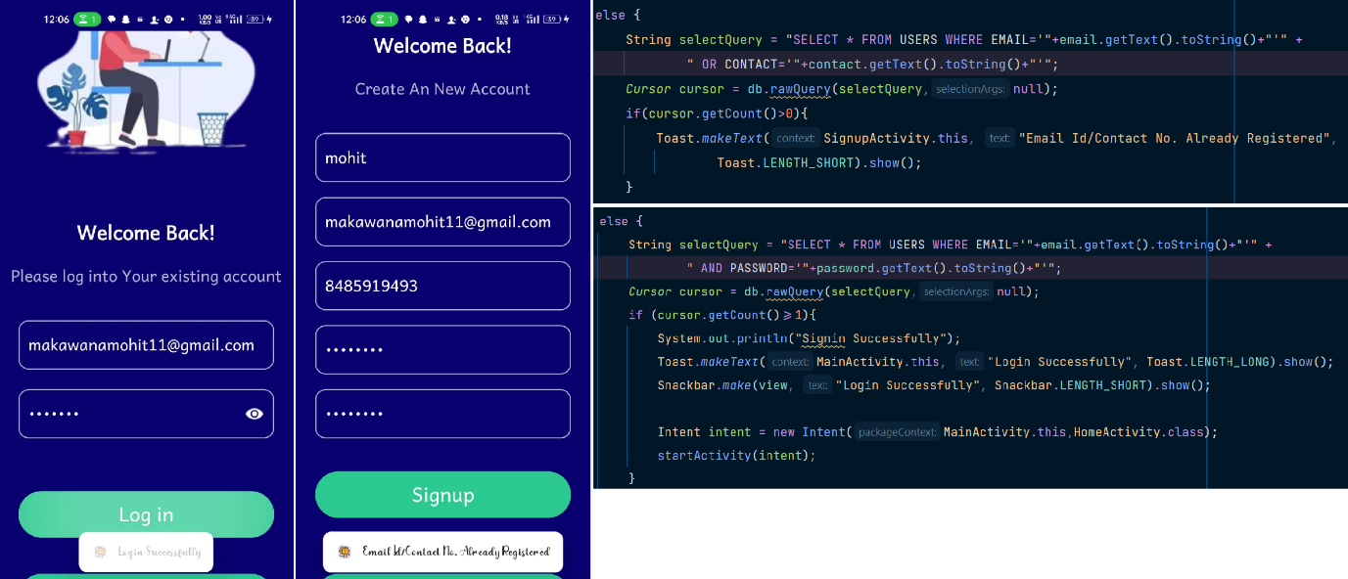**Select query and its uses**
* 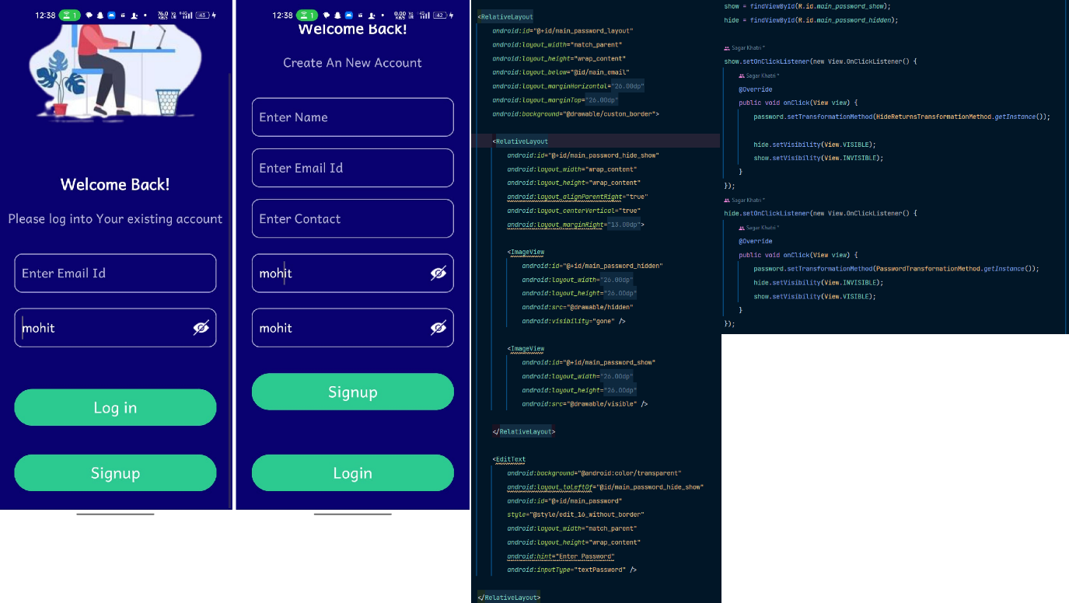**Making password Visible/ Invisible**
* 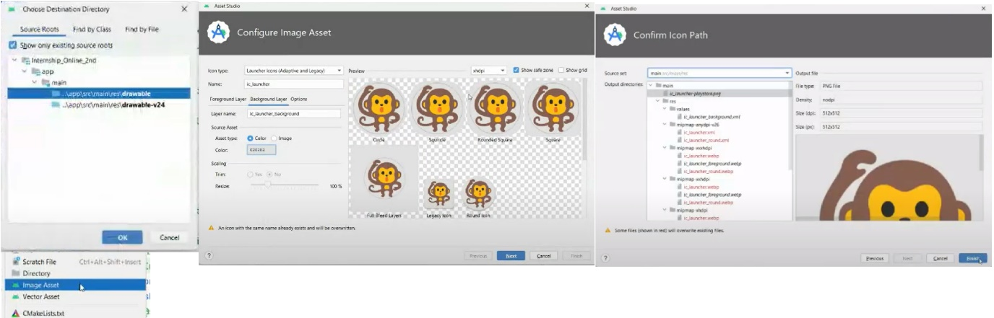**Set custom app icon to our app**
* **Date : 23th *August** Generating the signed version of app and publishing into playstore

**This steps is for generating app for playstore and for general share**

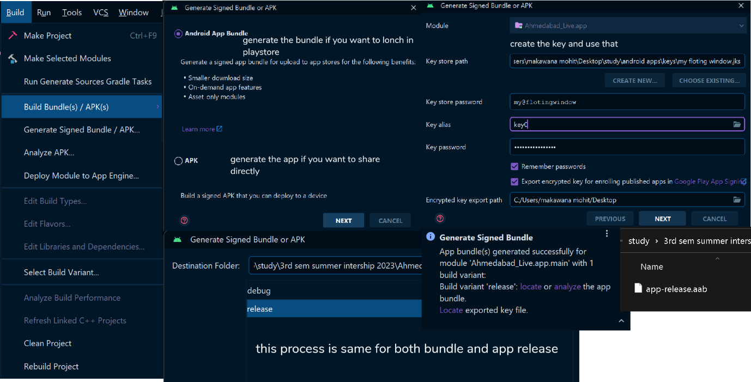

**The steps for post in playstore is given below**

* **Make googel console account [you have to pay US 25 dollars]**
* **Generate package from android studio**
* **Post the app with filling all details about the app**
* **References**
* [**https://developer.android.com/docs**](https://developer.android.com/docs)
* [**https://brainybeaminfotech.com/**](https://brainybeaminfotech.com/)
* **App link**
* [**All sessions link**](https://projectmohitmalavitswd.on.drv.tw/www.sem1SWdmicroproject/intership.html)
* [**https://projectmohitmalavitswd.on.drv.tw/www.sem1SWdmicroproject/intership.html**](https://projectmohitmalavitswd.on.drv.tw/www.sem1SWdmicroproject/intership.html)